|  |  |
| --- | --- |
| **Name** | Tamarraw Redfern |
| **Class** | Systems Analyst Fall Cohort |
| **Assignment** | Assignment 1003 |

1. **Write the four data types for storing strings and when to use them.**

|  |  |  |
| --- | --- | --- |
| **Data Type** | **Use** | **Example** |
| **CHAR** | Use for fixed characters | English Zip Code, SSN |
| **NCHAR** | Use when data size is consistent for multiple languages | License in another language |
| **VCHAR** | Use when data varies considerably | English names |
| **NVCHAR** | Use when data varies considerably for multiple languages (incl English) | City/Country names in another language (i.e. Chinese) |

1. **What is Cloud platform?**

A platform which allows for storage of your data on a virtual enterprise versus it being stored on your local computer.

* 1. **What is the use of it**?
     1. It allows for remote connection. Using this service allows you to buy resources and

connect to it for the time period in which you need it (versus buying additional

storage or computer). This offers a pay-as-you- go benefit to the user.

* 1. **What are the different Cloud platforms**?
     1. Microsoft Azure
     2. Amazon Web Services (AWS)
     3. Google Cloud
     4. IBM Cloud
     5. Oracle Cloud

1. **Create two databases – HRMS and CS**

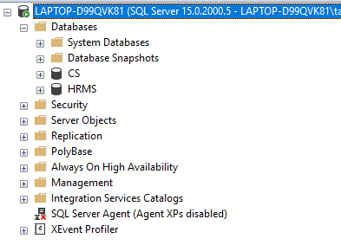

1. **Declare and assign values for integer data Type and varchar data type**.
   1. **Int Data type**

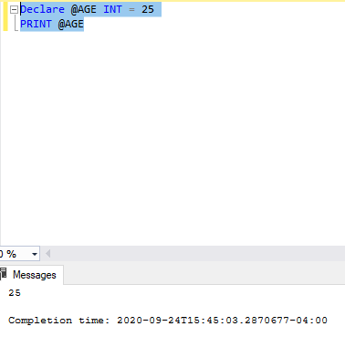

* 1. **Varchar Data Type**

